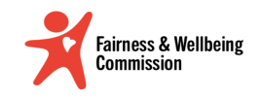
The Doncaster Fairness and Well-being Commission
Session 7: Opportunities and Recommendations to Improve Fairness for Doncaster’s Children, Young People and Families
Date/ Time: 8th September 2023 at 1pm
Venue: The Quaker Meeting House, Oxford Place, Off St James’ Street, Doncaster, DN1 3SL

In attendance:
Chair | Rt Hon. Dame Rosie Winterton DBE | Member of Parliament for Doncaster Central
Vice Chair | Rachael Leslie | Deputy Director of Public Health; City of Doncaster Council
 | Riana Nelson | Director of Children, Young People and Families; City of Doncaster Council
 | Beryce Nixon | CEO; Exceed Learning Partnership
 | Cath Witherington | Chief Executive; Voluntary Action Doncaster
 | Emma Norton | Head of Policy & Corporate Affairs; Doncaster Chamber
 | Arshad Khaliq | Chair of the Ethnic Culture Fusion Network; City of Doncaster Council
 | Professor Ed Ferrari | Director of the Centre for Regional Economic and Social Research; Sheffield Hallam University
 | Professor Liddy Goyder | Professor of Public Health; the University of Sheffield
 | Courtney Helsby | Participation Officer; Partnerships & Engagement Team; City of Doncaster Council
 | Melanie Besford | Department of work and pensions

Apologies:
 | Phil Mettam | Doncaster Resident & Lay Member
 | Damian Allen | Chief Executive; City of Doncaster Council
 | Rupert Suckling | Director of Public Health
 | Professor Andrew Booth | Professor in Evidence Synthesis; the University of Sheffield
 | Dave Richmond | Chief Executive; St Leger Homes of Doncaster
 | Professor Parveen Ali | Professor of Nursing and Gender Based Violence; the University of Sheffield and Doncaster & Bassetlaw Teaching Hospitals
 | Heather Boyce | Chief Executive; Age UK; Doncaster
 | Anthony Fitzgerald | Executive Place Director; NHS South Yorkshire ICB
 | Owen Dungworth | Young Advisor; City of Doncaster Council

Supporting:

Jon Gleek | Head of Service, Policy, Insight and Change; City of Doncaster Council
Clare Henry | Public Health Principal; City of Doncaster Council
Hayley Waller | Policy and Insight Manager; City of Doncaster Council

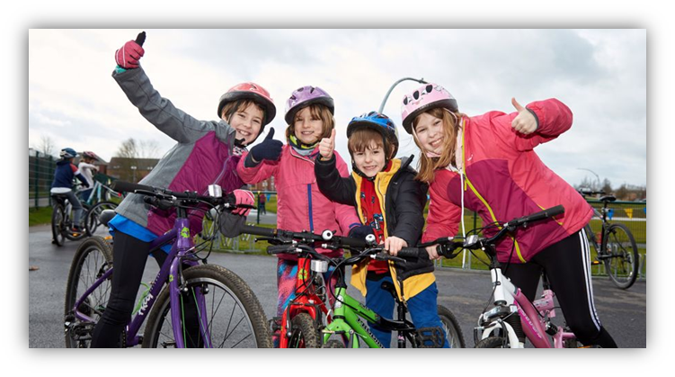
Welcome and introductions

Dame Rosie Winterton welcomed commission members to the final of the life course sessions with the aim of identifying opportunities to make life fairer for Doncaster’s Children, Young People & Families.

Dame Rosie introduced the CEO of the Exceed Learning Partnership & Schools Leader Beryce Nixon and Doncaster Council’s Director of Children, Young People and Families Riana Nelson as our speakers of the day; and asked commission members to contemplate during the session what kind of Doncaster we want to see in the future as well as ways that we can make changes to ensure that all young people in Doncaster get a fair crack of the whip.

Reflections of Session 6

Rachael Leslie reflected on & reminded the commission of the considerable data and evidence considered in our last session, including:
- “Aspirations” by Les Monaghan; Bringing to life the challenge of achievement for children and young people when their opportunities are limited.
- Doncaster’s Youth Councillors: Gracie Sneap & Alex Footsoy, presented some of the outcomes of their campaign about the cost of living & Health.
- Our discussion on ‘poverty proofing’ schools.
- The 3 dimensions to unfairness, defined as:
  - Young people are not held in the right esteem
  - It is unfair that we treat our young people differently
  - Time – the future belongs to our young people.
- The Data Walk which included details on Fairness related issues including:
  - The normalisation & increase in knife crime amongst young people
  - The stark differences in life expectancy across Doncaster
  - We don’t protect young people from highly addictive products
  - Poor access to NHS dentists
- The Root Causes and Opportunities for change identified in our personas; despite their individual differences, the personas shared a common experience of being overwhelmed by the compounding effect of intersecting issues.

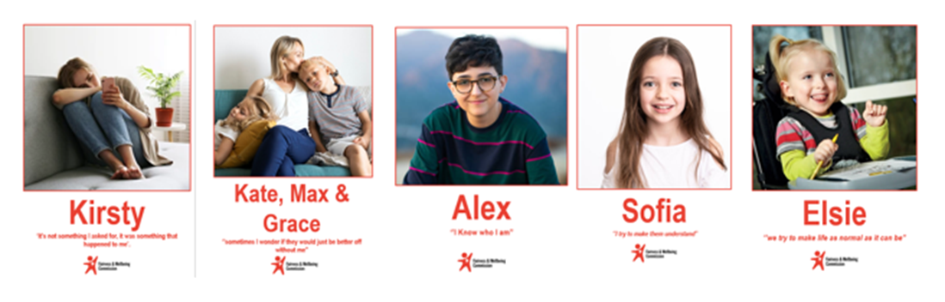
Panel: Understanding life through the lens of Doncaster’s Children, young people, and families
Reaching the Unseen Children
Beryce Nixon – CEO Exceed Learning Partnership
Speaking to the commission about her wealth of experience in education, Beryce gave a brief outline of some of the challenges and barriers to learning faced by children and young people in some of the most deprived areas of Doncaster as well as discussing the role and importance of schools in being able to support families and communities to overcome these barriers and support children to thrive.

Beryce highlighted some of the core values within her trust that nurture children and enable them to flourish:
- Stretching the mind
- Enriching the imagination
- Strengthening the body
- Nourishing the spirit
- Encouraging the will to do good
- Opening the heart to others

Beryce spoke to the commission about curriculum design and what makes a difference to learning as well as recommending to the commission areas that are important to focus onto successfully support children and young people in our communities:

Riana Nelson – Director Children, Young People and Families; City of Doncaster Council

Riana highlighted to the commission specific groups and themes to consider in its recommendations as well as talking to members about what is the current focus for children, young people and families in Doncaster. She set out Doncaster Councils four-point Vision for children in its communities:

- Our children are given the very best start in life by their parents and carers who are supported to optimise their child’s development.
- Our children enjoy good health and receive effective services as needed in order to optimise independence and the best health outcomes.
- Our children are well prepared for adulthood, access and engage in education, employment and training and contribute to their community positively.
- Our children live safely and happily within their families and where they cannot live at home, we are good corporate parents.

Riana went on to discuss specific issues and opportunities with the commission in relation to:
- Equality & Inclusion
- SEND
- Social Care
- Early intervention and prevention
- partnerships

Riana suggested that the commission focus on the following in their recommendations:
- Support the Youth Council campaigns.
- Support the partnership commitment to provide support as early as possible to children and families.
- Support the broad principle of shifting the focus towards a lifelong learning ecosystem model which is responsive to the needs of the local (and national) economy; recommend that SYMCA reflect this approach as they develop their forthcoming Sub-Regional Skills Strategy.
- Support the mental health and wellbeing offer to young people 16+
- Support creating opportunities for care experienced people to succeed
- Support the principles and strategic intent of the SEND Strategy to develop more effective responses at an earlier point.
- Support the development of Locality Inclusion Charters and a theory of change for all providers, agencies and businesses. Setting out how all parties will commit to improving the lives of children and young people who require additional support and will take responsibility for improving relational practice.
- Support the strengthening of young carers voice.

Observations:
- Role Models Matter: members talked about how role models are crucial, and the importance of a “windows and mirrors" approach. Everyone who works with children and young people should understand how much influence they have in shaping these role models.
- Supporting Communities: School leaders should be there to help parents and communities when they face hurdles in their child's learning journey; listening to and supporting all communities, especially those in vulnerable situations.
- School Leaders should be Civic Leaders that understand and address the challenges and needs of the local community that they serve.
- Better Education Standards: schools across the city should follow some basic standards to improve education for everyone. Right now, some national academies have a one-size-fits-all approach that leaves disadvantaged communities behind.
- Let Kids Choose Their Learning: The Commission discussed how letting young people choose what they want to learn can help reduce exclusions and lead to better results.
- Teaching Values in Schools: Commission members touched on the idea that schools should also teach values like love, empathy, and understanding. This helps children understand who they are in the world, something that might be missing at home.
- Avoiding Labels: It was noted that words like "disadvantaged" are often used as an excuse for poor outcomes and create stigma. The focus should be on helping all children overcome the obstacles they face.
- Community Leadership: Commissioners talked about bringing leaders together to better understand their communities. The blanket "zero tolerance" approach in some academies might not always be the best way to solve problems locally.
- Connecting Education and Jobs: members discussed how education should be more connected to what employers need; maybe we need to be more ambitious in how we define success in the economy.
- Different Dimensions of Economic Success and Child Poverty: commissioners considered whether child poverty is about more than just not having enough money; It could also be not having love, ambition, care, or the right resources to grow.
- Creating a Common Charter: commissioners felt that there should be a shared plan to help people, communities, and the planet thrive. This means speaking up for what we believe in and supporting common goals.
- Challenges with Current Policy: It was noted that current policy doesn't make it easy to have a common plan such as a local charter to improve fairness.
- Empowering Kids with Choices: Some children within Doncaster’s communities have never experienced choice in their lives; the power of choice should not be underestimated
- Holistic School Cultures: it was noted that some schools focus on the big picture and the whole child, while others have a narrower view. It is important to make sure all schools have a consistent approach and clear responsibilities.
- Local Inclusion Charters: The commission discussed the idea that schools should work more closely with their communities and considered recommending making local inclusion charters.

Children and Young People – a brief overview of themes
Professor Liddy Goyder & Professor Andrew Booth; University of Sheffield

Professor Liddy Goyder presented approximately 15 best practice examples from communities/local government/ research literature all focused on children and young people, each responding to a suggestion made by the commission in the previous meeting.

Liddy provided a summary of examples plus activities & evaluation (where available) of each. The examples were designed as a starting point for ideas/discussion.

Liddy noted that it was also important to identify unintended consequences (e.g., Youth Councils) or good ideas that may under-deliver (e.g., School holiday feeding programmes)

ACTIVITY: Recommendations for a fairer future
Commission members were asked:
For this session think about what kind of place do we want to shape for the future children of Doncaster
- Think about possible futures and preferred futures
- Today we want you to be visionary and think about what needs to change to make a transformational shift from what we have now.
- Break from past traditions. What pockets of existing practice/approaches we have now could lead to a better future? How do we grow these?
- What do we see in Doncaster today, which offers a glimmer of hope, and could become more prominent in the future if we supported it to grow?
Commission members worked in small groups to start to develop ideas and recommendations to bring about a fairer future for Doncaster’s Children, Young People and Families. Recommendations considered and discussed in this session focused on 7 emerging themes:
- Fostering Inclusive Education
- Empowerment and Support
- Life skills and Enrichment
- Extracurricular Opportunities
- Collaboration and Community Engagement
- Addressing Emerging Trends and Barriers
- Shared Vision and Collaboration
The recommendations in these theme areas aim to create a more inclusive and supportive environment for children and young people, emphasising their individual growth, empowerment, and overall wellbeing.

